Implement the class Bill based on the class diagram and description given below.

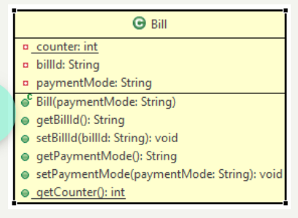

**Method Description**

**Bill(String paymentMode)**

* Initialize the paymentMode instance variable with the value passed to the parameter.
* Generate the billId using counter. The value of billId should start from 'B9001' and the numerical part should be incremented by 1 for the subsequent values. Initialize the counter in static block.

Implement the appropriate getter and setter methods.

Test the functionalities using the provided Tester class. Create two or more Bill objects and validate that the billId is being generated properly.

**Sample Input and Output**

**For constructor**

**Input**

For first Bill object

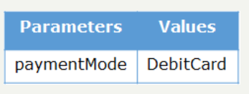

For second Bill object

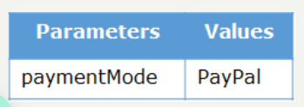

**Output**

